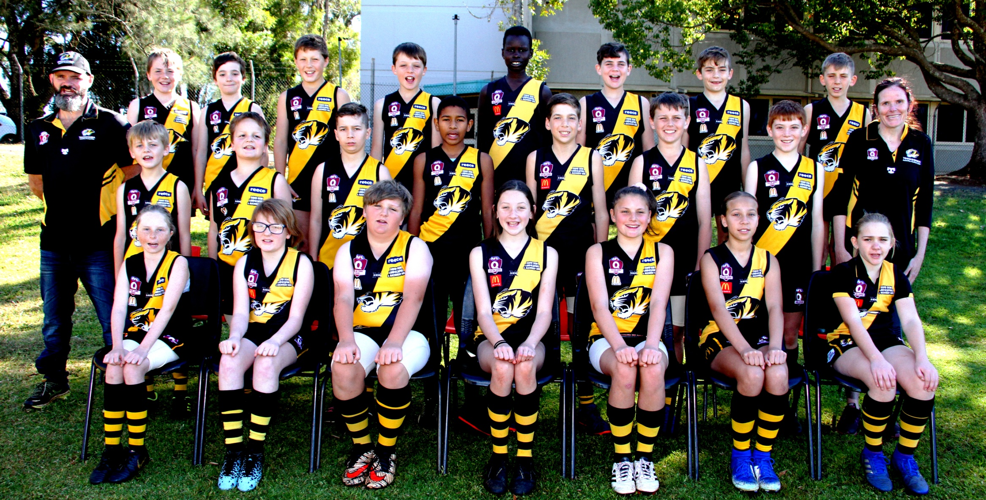

Back row L to R Elijah Miller, Aiden Diprose, Jackson Stewart, Will Anderson, Rinny Madut, Hayden Crookey, Zaiden Smith, Will Turner.
Middle row L to R Cameron Diprose (Coach) Noah Miller, Lael Lawrence, Brayden Howell, Abdul Matala, Jacob Bell, Riley Becker, Sean Gaffney, Jenn Bell (Manager)
Front row L to R Aleisha Bell, Abby Sykes, Ben Steinberg, Kalea Anderson, Kathryn Elliot, Sienna Wilson, Jasmin Mantiet

Absent Cairo Turner, Flynn Turner, Tyson Jenkins, Ben Jenkins, Jack Adamson

