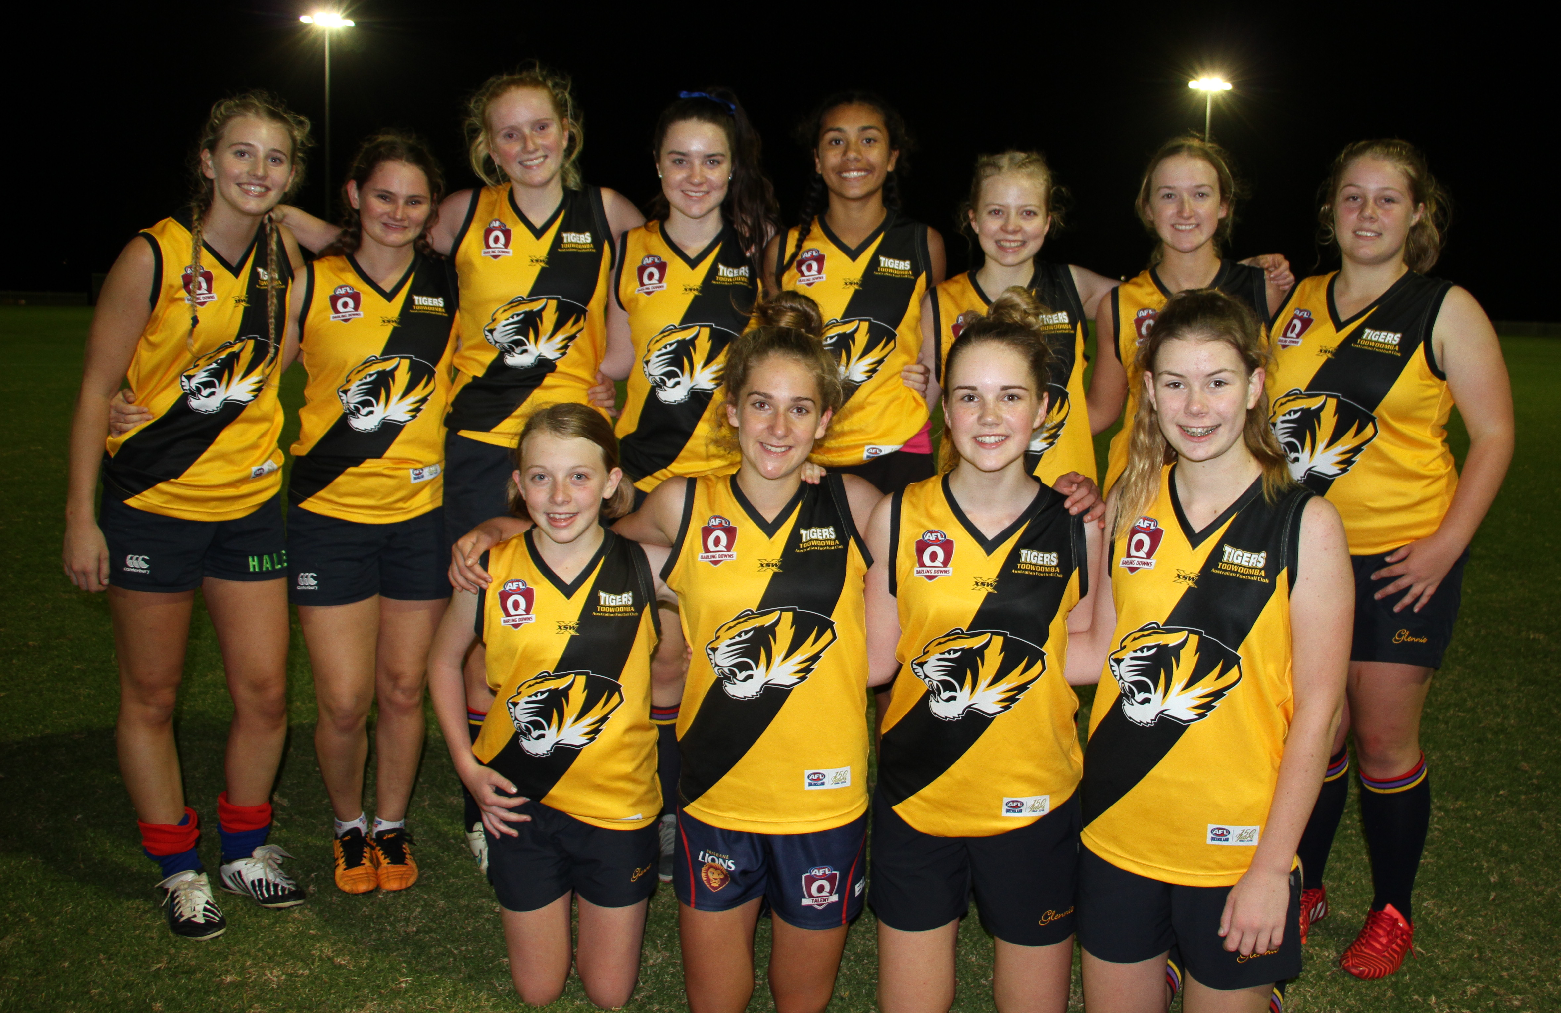



Back Row (L-R) : Georgia Marsh, Pippy Donaldson, Lucy White, Kaitlyn Lansbury, Zimmorlei Farquharson, Namoi Ryan, Maddie Malone, Laura Darlington

Front Row (L-R ): Miranda Broadfoot, Tiarna Jericho, Amanda Taylor, Amber Pugh

