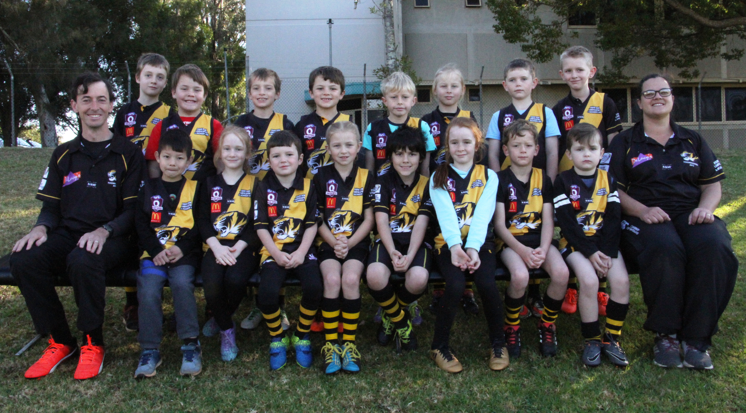




Back Row L – R : Lachlan Whyte, Cobi Pearson, Caleb Bell, Oliver Anderson, Alex Duncan , Jackson Revill, Thomas Cossins, Braeden Clark
Front Row L-R: Andrew Bell (Coach) Eric Allison , Lillyann Harbort, Mitchell Whyte, Amy Becker, Wyatt Colley, Abigail Harbort, , Archie Skewes
Brayden Goulding, Jes Lawrence (Manager)
Absent : Olivia Haywood, Lelain Graham,Darcy Haywood

